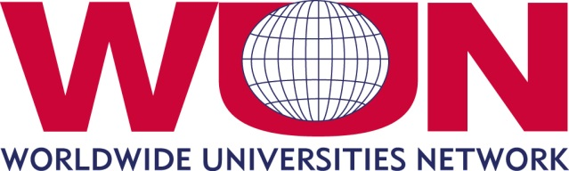

WUN Research Development Fund (RDF) 2016

Application Form Guide

Directions | - This form provides a guide to the questions that will appear on the online application platform. Applications for the 2016 Round will only be accepted via the online application form, with a firm deadline of 28 October 2016 at 5pm GMT.  - The online form will launch on 1 July and information on accessing the online application portal will be distributed by the Secretariat before this date.  - Responses should be completed using lay terms. It is likely that one or more reviewers will not be a specialist in the field to which the program pertains.  - Do not attach additional pages to your application, other than those specifically requested.  - When submitting applications, the Principal Investigator is confirming the commitment of partner institutions and people named on their application.  - Before commencing applications we strongly encourage applicants to discuss proposals with their local WUN coordinator
Program Title
Principal Investigator at the lead institution | Title | Professor/Associate Professor/Dr/Mr/Mrs/Ms
 | First Name
 | Last Name
 | Department
 | University
 | Contact phone | Include country code and area code
 | Contact email
Partner Institutions  Name of partner university and lead collaborator at that university. | WUN partners | University name | Lead collaborator name
Non-WUN universities
Include country location
Other partners
Corporate, government partners etc
WUN Global Challenge
Funding requested  (max. £12,000) | £
Total matched funding pledged by WUN and other partners | £  If successful, funding will be dependent on the applicant providing evidence of this matched funding in the form of official letters of support. Where an applicant is unable to provide these official letters of support the WUN RDF grant will not be awarded.
Program Summary
Enter a summary for non-specialists (maximum 300 words).
What do you want to do? Why do you want to do it? How will you do it? What is the expected outcome?
Program Description
In language intelligible to the non-specialist, describe what you intend to do, and how the effort will contribute to building or strengthening sustainable international research collaborations. Explain how it is new and important to scholars and/or society generally. Explain what you expect to be the outcome of the work, and its scholarly or other impact. Explain how (and, if relevant, where) you and your collaborators will undertake the work. Where special skills or techniques are required at any point, make clear who will supply them (maximum 1000 words).

Relevance to WUN Goals
Explain briefly how the program aligns with WUN strategic objectives and how it addresses a WUN Global Challenge. (maximum 300 words).

Sustainability
Outline how the program will build long-term, sustainable international relationships based on genuine commitment by the research partners. Describe the sustainability plans, including specific future funding levels and sources to support the research collaboration after the RDF seed monies expire (maximum 300 words).

Teamwork
Outline how the program team will be led and constituted, including the participation of early career researchers and PhD students (maximum 300 words). In addition, please include a link to the CV/profile page of each member of the research team.

Anticipated Outcomes
List the key performance indicators (KPIs) of this project (eg: joint external funding applications, joint publications, postgraduate training, policy input, novel technologies etc.) (maximum 300 words).

Program Timeline
(maximum 100 words per month)
Pre-award
January 2017
February 2017
March 2017
April 2017
May 2017
June 2017
July 2017
August 2017
September 2017
October 2017
November 2017
December 2017
Beyond award

Accompanying Information Checklist
Program budget outlining key areas of expenditure (1 page maximum)
CV of principal investigator (1 page maximum)
Statement of support of collaborating institutions
I confirm that as Principal Investigator I have discussed this application with my institutional coordinator and confirmed that it has been approved as one of the (maximum) three applications from my institution.

